Ye Olde Cemetery

491 Main Street

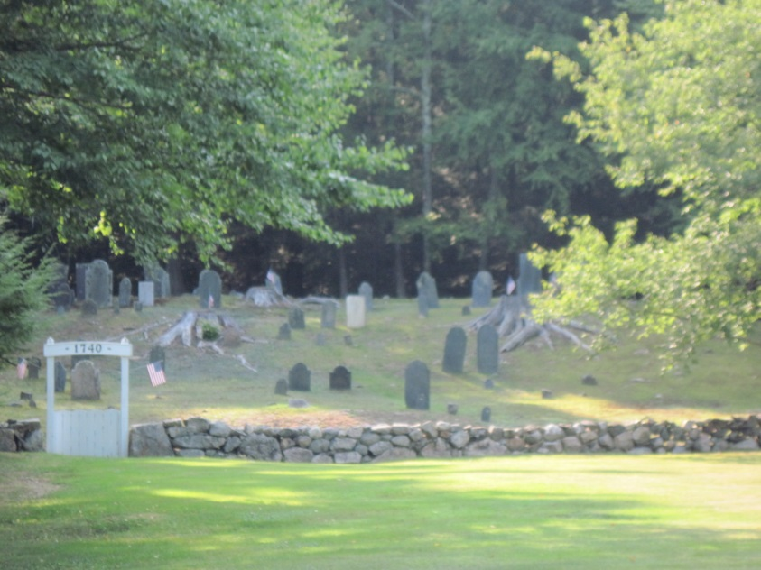

This ancient burying ground is located slightly north of the Old Meeting House on the opposite side of the road. This cemetery was laid out while this area was still a part of Kingston. It is the final resting place of the town’s (Hawke’s) first minister, the Rev. John Page, as well as numerous Revolutionary soldiers. Burials date back to 1740. The last burial is believed to have been in 1834.

