White Schoolhouse/Sanborn Library

44 Beach Plain Road

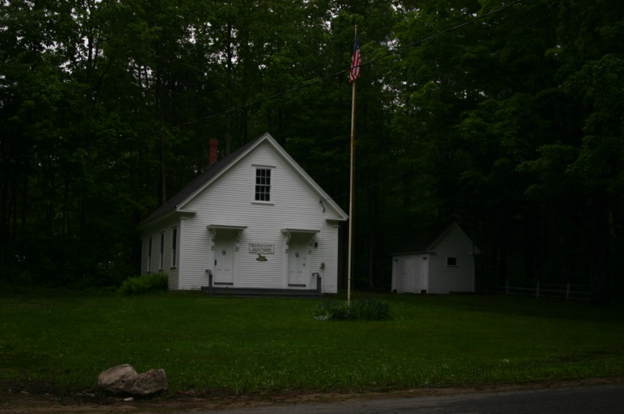

In 1896 the town’s school district warrant included an article, which was approved, to build a new schoolhouse in the north part of the town. The town then purchased the land on Beach Plain Road from Marilla Brewster for $100 in 1895 and the White Schoolhouse was built just prior to 1900. It was used to teach students in grades 1-8 from the north end of town until 1939. In 1950 town voters approved a school district warrant article to sell the school property to the North Danville Village Improvement Society (VIS) for $1.00 with the condition that if the VIS ceased to be active, the property would be deeded back to the town for the same amount. A library, conducted by the VIS and financed by the Mary Jane Sanborn Fund, has been housed there ever since.

