WEBSTER STAGECOACH STOP AND STORE
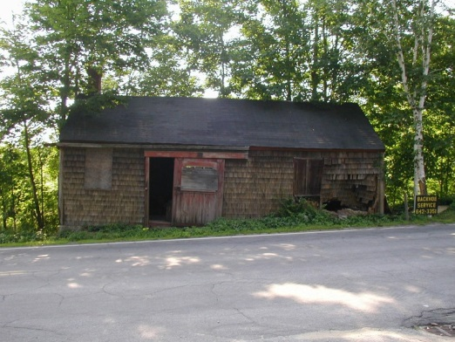
You may have noticed the small building on Route 111A in Danville just across from Sandown Road. If so, you are not alone, as it has been there for some 200 years, give or take. You also may have read about it in one of our previous articles. With a little good fortune you will not see it there in exactly the same spot in the not too distant future.
The building was a stagecoach stop operated by Nathaniel Webster, a cousin of Daniel Webster, throughout most of the 1800’s. Nathaniel was the first designated postmaster of Danville (then Hawke), from 1825 to 1836. Webster conducted postal operations from his homestead, and maintained a small general store in this small building. Town history describes it as being a layover for scheduled stagecoach routes passing through Danville and delivering the mail, where coach passengers could buy refreshments and provisions while the horses were being rested, watered and fed in the adjoining stable. The stable was removed and reconstructed elsewhere in the 1980’s. The building remains essentially as it was built, providing a snapshot of the site of the first recorded postal activity in town, as well as a facet of early public transportation in a by-gone era. It is possible, although not confirmed, that the building may be the last remaining of such structures in New Hampshire in its original state.
The building is now precariously close to the highway that has grown in width over the years. It has suffered the usual deterioration from the elements, and the ravages of increasing traffic and road maintenance. It was struck by a vehicle several years ago, and again in 2005. The owners had the damage professionally restored, but it is only a matter of time before it is struck again. It must be relocated if it is to continue to exist for future generations.
The heirs of Melton and Marcia Sanborn, the current owners, have offered to save the building and donate it to the Town of Danville provided it is relocated. The most logical site is the small triangle of land directly across Route 111A, now owned by the Town, but originally part of the Webster homestead. This would involve a minimal distance to move the structure, and because it would continue to be on what was originally Webster property, it would not alter the sense or feel of its place in history.
The Danville Board of Selectmen has requested the Heritage Commission put forth a plan to accomplish such a move. As a first step, we have made application to the New Hampshire Division of Historical Resources to place the structure on the New Hampshire Register of Historic Places. As next steps we expect to seek historical grant money to help make this relocation a reality.
This small building is the only remaining vestige of the first postal service provided in Danville. Its significance is enhanced in that it has remained in almost its original state for approaching two centuries now. With its new physical setting, safely away from traffic, at the intersection with the restored Webster house directly across Sandown Road, one can easily be taken back in time almost two centuries when our postal service was in its infancy, and the only means of public transportation was by stagecoach; a feeling of genuine historic presence for Danville.
We will keep you posted as we continue our efforts to save this venerable historic treasure.

