Webster Stagecoach Stop & Store

1 Sandown Road

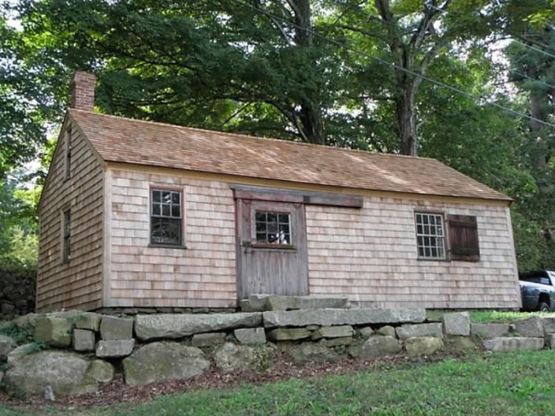

Built circa 1820-1830, the stagecoach stop and store was originally located diagonally across Main Street (Route 111A). It was an intermittent stopover for wagons and stagecoach traffic on the Concord to Portsmouth route. It was built and owned by Nathaniel Webster, a cousin of Daniel Webster, who was the first U.S. postmaster of Danville from 1825 to 1836. Originally there was an adjacent stable where horses would be watered and fed, while any passengers could buy goods from the tiny general store that was half of the small building. The other half was a workshop. The stage stop was discontinued when railroads gradually replaced stages in the mid 19th century. Though Nathaniel died in 1871, it is believed operation of the general store by family members continued until at least the late 1800’s. The building has been named to the New Hampshire Register of Historic Places. It was saved from the ravages of the highway and relocated to its current site (which was originally part of the Webster homestead) in 2008 by the Danville Heritage Commission.

More information about the Stagecoach Stop and Store is available at the following links:

New Hampshire Preservation Alliance:
http://www.nhpreservation.org/component/content/article/230-webster-stagecoach-stop-a-store.html

Top 11 Most Important Historical Building Structural Renovations in NH
https://www.summitengineeringinc.com/top-11-important-historical-building-structural-renovations-nh/

Eagle Tribune:
http://www.eagletribune.com/news/local_news/historic-stagecoach-stop-will-be-moved-out-of-harm-s/article_d5a36086-e5a5-5362-b857-25368451deac.html

http://www.eagletribune.com/news/local_news/danville-group-honored-for-saving-stagecoach-stop/article_bbe8393b-8564-5eb2-9356-36365fcd99c4.html

http://northofboston.smugmug.com/keyword/stagecoach/i-DnQkqHt

