Tuckertown Revisited
March 11, 2008
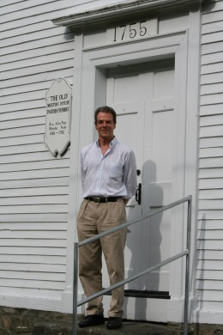
Have you ever considered going back some 200 years to where your ancestors lived, where they struggled with the hardships of the times, where they worshipped…where they died? What traces of your ancestors would you hope to find? Byron Tucker (pictured above) did just that in July of 2007 when he came here from New York City to visit Danville, the Old Meetinghouse, and the area known for two centuries by local historians as Tuckertown. Byron Tucker is a direct descendent of the Tucker family who lived here, and some of whom died here in the smallpox epidemic of 1781 and 1782.
Tuckertown Road, directly across from the Old Meeting House on Route 111A in Danville, is part of the town’s historic district. The road leads to a forested area where local legend has it a small settlement existed in the last quarter of the 18th century. A family by the name of Tucker lived near the end of the road, close to the Sandown line. For centuries the Tucker family has been linked to the tale of the unfortunate death and loss of Reverend John Page, the first and only resident minister of the Old Meeting House.
In 1770, Ebenezer Tucker, Sr. settled on 26 acres of land in Danville (then known as Hawke) with his wife, Deborah. They were later joined by two of their sons, Joseph and Ebenezer, Jr. and their wives, Susannah and Mary. Thirteen children were born to Joseph and Ebenezer, Jr. and their births are part of the Hawke vital records kept by Rev. Page. Ebenezer, Sr. died in 1776. His son Joseph died a year later in 1777 at the age of 38 and Ebenezer Tucker, Jr. became the sole surviving adult male in the family. Ebenezer, Jr. eventually left Hawke with his wife and children. His mother Deborah, Joseph’s widow, Susannah, and seven of Joseph’s children may have been the only Tuckers remaining in Hawke when tragedy struck.
In the winter of 1781 and 1782, a smallpox epidemic swept the surrounding towns and some Tucker family members were inflicted. Townsfolk in Hawke were terrified of the disease and were afraid to expose themselves to anyone who had it. Therefore, no one was willing to come to the aid of the Tuckers when they were left without food and firewood. The Reverend John Page, the first and only minister of the Old Meeting House, stepped forth and personally took the needed food and firewood to the Tuckers. While there he contracted the disease and succumbed to the deadly pox in early 1782. He left a widow and nine children. His death was sorely grieved and his selfless act of sacrifice served to immortalize him to the people of Hawke, and later Danville. The memory of this brave attempt to save the Tucker family has passed from generation to generation and continued to resonate and inspire us today. John Page, unquestionably one of Danville’s most prominent and notable citizens, was Harvard educated, and the University is now custodian of his diaries and journals.
Jonathan Tucker, Joseph and Susannah’s teenage son, had enlisted as a soldier in the Continental Army in 1779 and was away from Hawke fighting in the Revolutionary War when the smallpox tragedy struck his family during the winter of 1781/1782. By the time he was discharged in New York in 1783, the Tucker family structure was in a state of collapse and there was little to return to in Hawke. He collected a surviving 14-year-old brother, Henry, and returned to New York. The two Tucker brothers later met and married sisters in New York and settled there to raise their own families.
Thus we return to Byron Tucker, who we now know is a direct descendent of Jonathan Tucker. Last spring, Thomas W. Jones, PhD, a renowned genealogist and professor at Gallaudet University in Washington, DC, and Carol Baird of the Heritage Commission were communicating regarding Tuckertown. He brought to her attention the history of Jonathan and his brother Henry and provided new Tucker family data and genealogical information. Dr. Jones also revealed that he himself is a descendent of the Tuckers of Hawke, as are his cousins Byron Tucker and June Tucker Keller. This was an exciting discovery, as heretofore, we were unaware of Tucker family members who had survived the smallpox epidemic.
In July of last year, Byron Tucker came to visit Danville. He wanted to learn more about the Tucker family and why they were important to Danville’s history. All of the Heritage Commission members greeted him at the Old Meeting House, shown above, and then took him on a tour of the area where his ancestors lived; a return to one’s roots, some 200 years later. As the story was recounted of Reverend Page’s attempt to save the Tucker family, his own illness and death and the tragic loss that resulted for the town, Mr. Tucker commented, “My family will be a part of this history forever because of what Reverend Page did for them. He must have been a wonderful man.”
The Old Meeting House, its adjacent cemetery, Ye Olde Cemetery across the road to the north where John Page is buried, Tuckertown Road, and the adjacent forest area, was designated an historic district by the voters of Danville in 1999—in no small part because of events that happened over two centuries ago and the selfless dedication and sacrifice of the Reverend John Page in caring for the Tucker family. Byron Tucker’s visit reminds us that history is more than buildings or structures. History is also made up of people and events that long ago were connected to a special place.
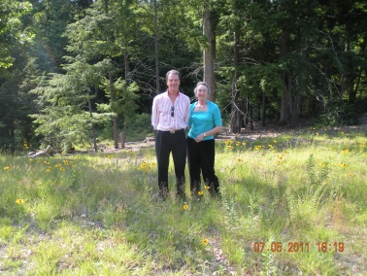
Byron Tucker and sister, Carolyn June Tucker Keller, in Danville (2011)

