THE OLD MEETING HOUSE
470 Main Street

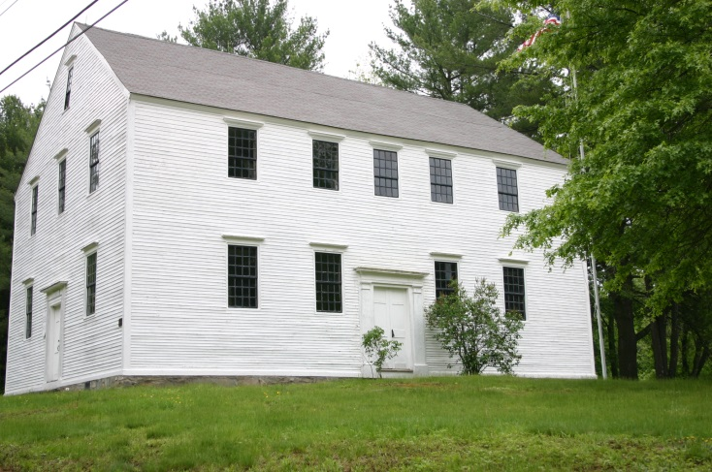
Danville’s historical crown jewel, this is the oldest original construction meeting house still standing in New Hampshire. Danville’s Old Meeting House was a meeting place for the townspeople for both religious and political purposes. The pulpit, the interior (excepting the pews on the first floor), and the exterior are all original. The bible cushion in the pulpit, the lock and key and the stenciling on the pillars are original. In 1912 the Olde Meeting House Association was formed to perpetuate the antiquity of the building. An annual Old Home Day service is held in the building each year. The building has been listed in the National Register of Historic Places since 1982. The state historic marker was dedicated on January 28, 1996.
Construction of the Meeting House started in 1754. It was built by 27 citizens who conveyed it to the town on June 6, 1760, free of charge. At the meeting held on that date it was voted to sell the privilege for sixteen pews to be put in at the owner’s expense, with the proceeds of the sale to be used for completion of the house. The prices ranged from 131 pounds to over 200 pounds old tenor, the highest being paid by Aaron Quimby for the pew next to the pulpit on the east. One side of the gallery was the men’s side, the other for women. The benches in the gallery were supposedly for slaves and indentured persons. The first town meeting was held in the building on March 10, 1760. Pews in the gallery were sold on September 14, 1761 and another sale is recorded on December 25, 1798. In the early 1800’s the pews on the main floor were removed so that dances could be held, although it has been said that there never were any held.
The interior was restored in 1936 through a generous gift of Lester A. Colby as a memorial to his mother. The material of the original pews, stored in various parts of the building, furnished plans and measurements so that the restoration is practically identical with the original. Mr. Arthur Tuck and Mr. Harry Greenwood did the actual work and used much of the original material.
Regular church services in the building ceased about 1832 and the last town meeting in the Old Meeting House was held in 1886. During town meetings the moderator and town clerk occupied space in front of the pulpit and the folding table served as a desk.
More information about the Old Meeting House can be found in the following links:
- An extensive report on the building authored by James L. Garvin, the renowned architectural historian who formerly served in that position at the New Hampshire Division of Historic Resources and also served as a curator at the Strawberry Banke Museum:
http://www.james-garvin.com/images/Danville_Meeting_House_Report.pdf
- First Period Colonial – Robert L. Pothier, Jr.
http://www.firstperiodcolonial.com/Meeting%20Houses/meeting_houses.htm
- A Project on Colonial Meetinghouses of New England by Large-Format Photographer and Author, Paul Wainwright:
http://www.colonialmeetinghouses.com/mh_danville.shtml
- THE GREAT BUILDINGS COLLECTION:
http://www.greatbuildings.com/buildings/Danville_Meeting_House.html

