The Beehive Hut
(Off Hersey Road)
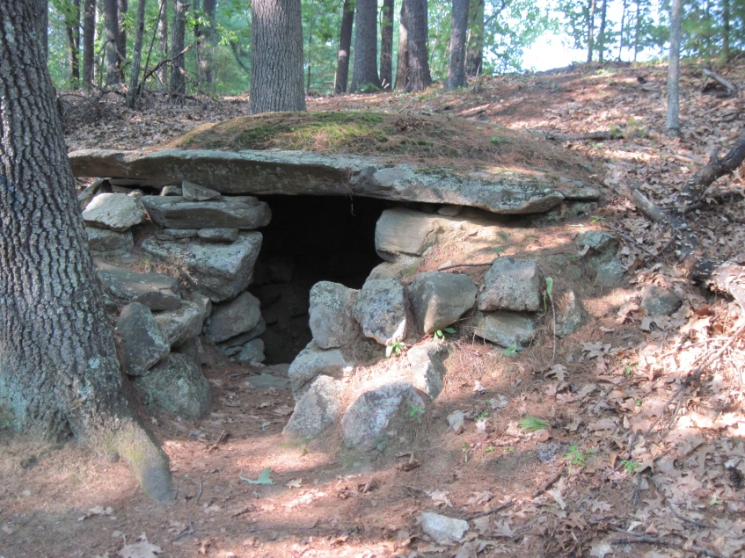
This man-made stone enclosure is believed to have origins in very early times, although its exact age and purpose have yet to be determined. It is similar to stone structures found throughout New England, such as those located at America’s Stonehenge in Salem, New Hampshire. Set into the side of a hill and facing southeast, it is small but has an unusual depth of approximately three feet. Its roof consists of one single and very large stone. Located very close to the structure are some huge and impressive natural outcroppings of ledge and stone that provide an impressive view from the top.
More information about the Beehive Hut can be found at the following link:
http://westerngeomancy.org/danvilles-beehive-hut/

The detailed Internet article at this link was written in 2015 by Grahame Gardner, who is a professional dowser and geomancer specialising in house-healing work involving geopathic and technopathic stress, and the creation of sacred spaces. He is a Registered Tutor with the British Society of Dowsers, is listed on their Professional Register, and served as President of the Society from 2008-2014. He is also a founder member of The Geomancy Group. This article is from his personal blog Western Geomancy.)

