The Old Red Schoolhouse

613 Main Street

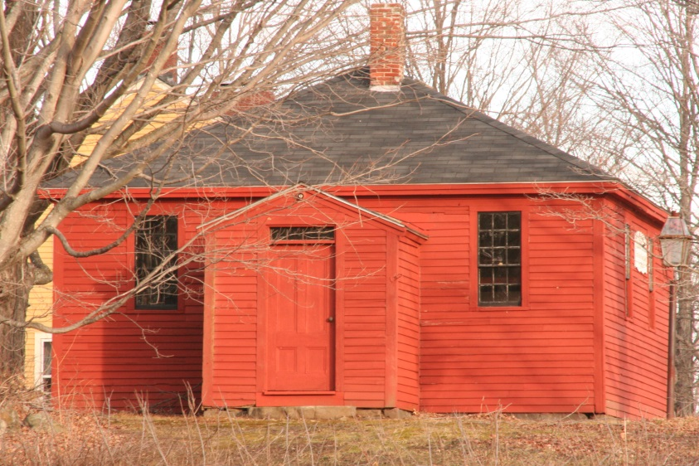

The schoolhouse now standing dates from 1835 and has become known as the Old Red Schoolhouse. It stands on the site of a schoolhouse that was built in 1789 as a permanent school and resulted in public taxation to support it. The original schoolhouse burned in 1834. In 1835 the town voted to raise $300 to build a new schoolhouse at the site and the building that now exists was constructed as a public school in 1835. Over the years it has also been called the District #1 School or the North Danville Little Red Schoolhouse. The double pine desks that are in the building today are the ones that were used by many generations.

