Old Meeting House Cemetery
(Behind the Meeting House)
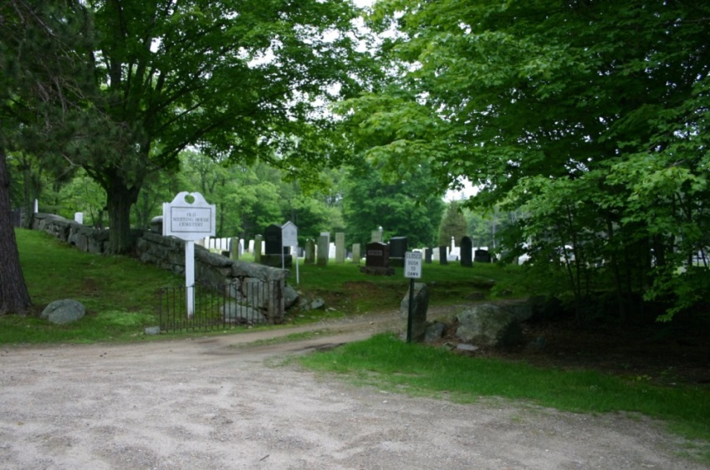
Adjacent to the Meeting House is the Meeting House Cemetery, the town’s second oldest public cemetery, with burials dating back to 1817. Families of early settlers and their descendants, town dignitaries and officials are buried here.

