North Danville Union Church

42 Beach Plain Road

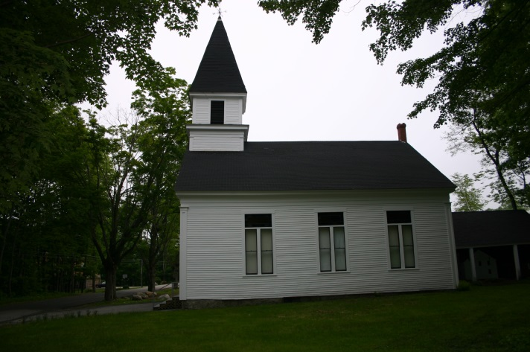

This church was organized in 1850 by the Union Religious Society. No one denomination could gather enough support to build a place of worship alone, so they joined together and built this building in the same year. The Sundays were divided between the Freewill Baptists, Methodists and Congregationalists. Original shareholders paid $25 each to build the church. When completed the pews were auctioned off. Most pews brought $6, but some sold for as little as one cent. The building was extensively renovated in 1892 and the kerosene chandelier was installed in 1894. The horse sheds were added to the rear in 1903. In 1938 the hand-pumped pipe organ was installed as a gift from the Bakie brothers of Kingston, NH. The pipe organ is listed in the Register of Antique Organs.

