LITTLE RED SCHOOLHOUSE
380 Main Street
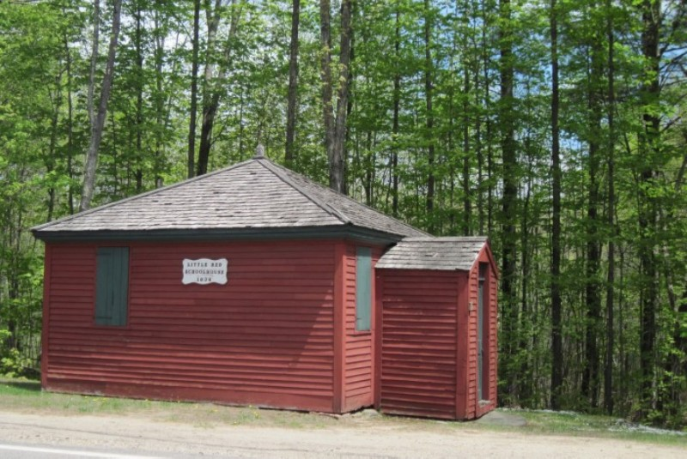
Danville’s Little Red Schoolhouse is associated with an important time period during the 1800’s when New Hampshire communities began to develop plans for formal public education and public school facilities that would be available to all children. Prior to that time, early schooling had generally taken place in the form of “moving schools,” usually in private homes and conducted when teachers were available; children attended when they could but there was no requirement.

The Little Red Schoolhouse, also known as the Middle District or Centre School, was built in 1834 after the Parish of Hawke (now Danville) voted to create three district schools to provide education for children in all sections of town. The Little Red Schoolhouse served as one of the town’s district schools until it closed in 1902. It was the custom for such district schools to be administered by the selectmen, who attended to the finances, while a separate Prudential Committee handled the curriculum. Initially in Danville the selectmen managed the finances and a “Superindenting” School Committee oversaw operation of the schools. By the late 1800’s a Board of Education had been established to manage both the finances and operation of the town’s schools. Danville’s town reports contain yearly accountings of the Board of Education’s achievements in educating the children in much earlier and simpler times.

These schools would service eight grades of students, who were taught physiology, composition, history, grammar, geography, arithmetic, penmanship, spelling, and reading by just one teacher. Town reports indicate that Danville’s Little Red Schoolhouse generally served 9-10 elementary students. The first teacher in the school was Miss Levinia Sanborn, and the last, in 1902, was Miss Mabel Warner. The school year consisted of thirty weeks, with a schedule fashioned around harvest time and spring planting time, a testament to a way of life built around agricultural schedules.

One room schoolhouses were Spartan with few amenities, usually limited to heat and a privy. Danville’s Little Red Schoolhouse originally had a fireplace on the outside for winter heat, which was replaced at some time with a pot-bellied stove. The building also once had an attached woodshed and privy. Its interior school room was furnished at the time with early double pine desks with bench type seats. The floor of the room was inclined from the back to the middle at an angle of twelve to fifteen degrees. The room was well lighted by seven windows and once had a fireplace on the outside for winter heat.

In addition to general maintenance and upkeep, the building has undergone restoration on several notable occasions. The building was restored by vote of the town in approximately 1940 and again by the Danville Grange as a community project in 1967. An open house was held in August 1967 and Miss Mabel Warner, the last teacher at the school in 1902, attended. In 2007 the exterior of the building was painted by a Danville Boy Scout as his Eagle Scout project. In the summer of 2014 the town replaced the wood shingle roof and made numerous repairs to the exterior boards. The town continues to maintain the building as a historic site to visit and a meeting space for occasional use.

Danville’s Little Red Schoolhouse was listed in the New Hampshire State Register of Historic Places in October of 2015. Benefits of being listed on the State Register include special consideration and relief from some building codes and regulations, designation of the property as historical (which is a pre-qualification for many grant programs), and acknowledgement of a property’s historical significance in the community.

