DANVILLE TOWN HALL
210 Main Street

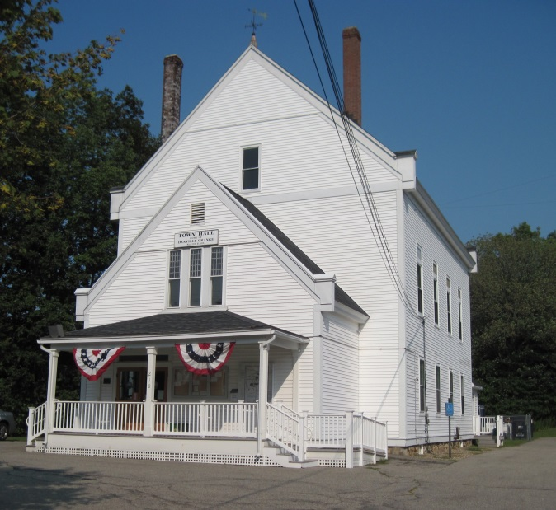
Danville's Town Hall was designed and constructed in 1886 to accommodate the "modern needs" that the venerable Old Meeting House, with no plumbing and cumbersome seating, could no longer provide. The "Town House", as it was then called, was designed with an auditorium on the second floor that became very popular and was used for a wide array of civic and private functions. It became the heart of civic and social activity for the town for decades to come. The first floor of the building has always chiefly been used to conduct the town’s official business. At one time the room now used by the town clerk was a “lockup or jail” and the town’s library, in its earliest days, was housed in the room now used as the selectmen’s office. Space on the first floor now includes offices for the selectmen, town clerk and tax collector, as well as a meeting room for the business of various town boards.

