Samuel and Peter Sargent Cooperage Shop
44 Beach Plain Road

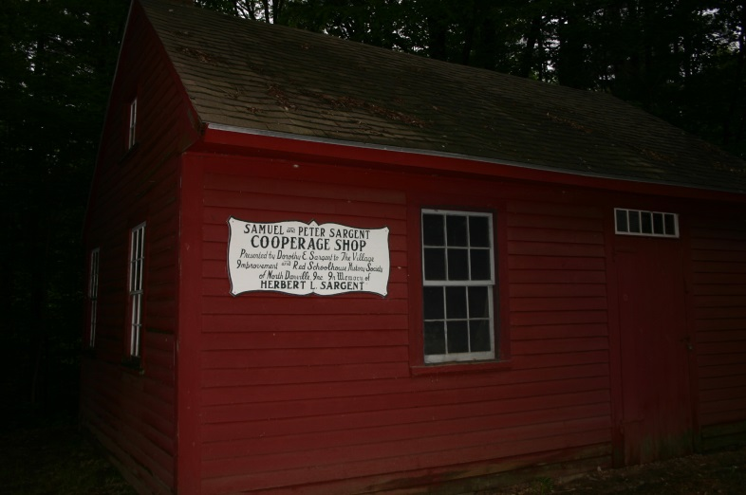

The Sargent Cooperage Shop was built about 1850 at Elm Farm, 599 Main Street and was operated by brothers, Samuel and Peter Sargent. Barrels and ladder back chairs were made here and sold in Amesbury and Newburyport, Massachusetts. In 1968 the shop, together with its original furnishings and tools, was given to the North Danville Village Improvement and Old Red Schoolhouse Historical Society by Mrs. Herbert L. Sargent, along with two acres of land on Beach Plain Road, to which the shop was moved. The gift was made in memory of Herbert L. Sargent. The shop was restored by members the North Danville Village Improvement and Old Red Schoolhouse Historical Society and dedicated on September 20, 1975.

