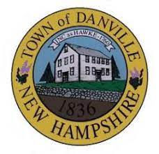
The Town of Danville Zoning Board of Adjustment is currently seeking Alternate members to join the Board.

All interested parties, please inquire within. Applications are available in the town clerk’s office.

