FY2021 DANVILLE BUDGET COMMITTEE
Minutes of our December 22, 2020 meeting

Chairman Tom Billbrough called this meeting of the FY2021 Danville Budget Committee to order at 7:30 PM, with the following members present:

Tom Billbrough * | Present | Sue Overstreet | Present (via Zoom)
Rob Collins ** | Late (via Zoom) | Jeff Steenson | Present (via Zoom)
Sheila Johannesen *** | Present

* Chairperson
** Vice Chairperson
*** BOS Representative

The first subject of discussion was a review of the minutes from our December 15th, 2020 meeting. At the conclusion of our review, Jeff made a motion as written. Sue seconded the motion and the motion carried unanimously (note: Rob came in just after our vote on the minutes).

We then proceeded to review the proposed FY2021 Highways & Streets budget (account 4312), Jim Seaver and Andy Ward were present to answer any questions. At the conclusion of our review, Rob made a motion to accept a modified budget in the amount of $698,724 as follows:

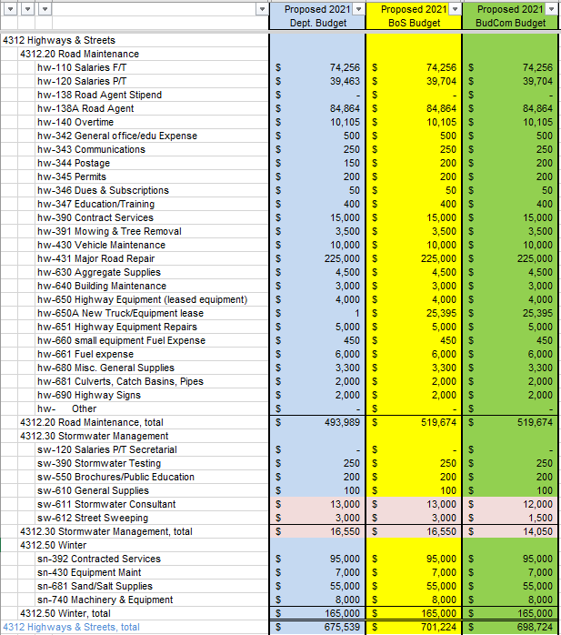

Jeff seconded the motion and the motion carried unanimously.

We then proceeded to review the proposed FY2021 Cemeteries budget (account 4195). At the conclusion of our review Rob made a motion to accept the proposed budget in the amount of $23,450. Sue seconded the motion and the motion carried unanimously.

We then had a brief discussion on the proposed FY2021 Personnel budget (account 4155). It was noted that there was a very large increase to the dollars proposed for per-230 (NH Retirement System), which is the retirement fund for full-time police officers. (Note: the budget went from $57,751 in 2020 to $113,200 in 2021, an increase of 196%. At a rate of approximately 25% of the total full-time salary, this amount should be around $100,000, not $113,000). Sheila informed us that the Financial Director was asked to look into this, so we agreed to table our discussion on this budget.

With nothing further to discuss we adjourned the meeting at 8:45 PM.

Our next meeting will be Tuesday, December 29, 2021 at 7:30 PM in the Town Hall where we will complete our review of the remaining 6 proposed FY2021 budgets:

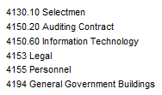

Respectfully Submitted
Tom Billbrough
Chairperson

