FY2021 DANVILLE BUDGET COMMITTEE
Minutes of our December 29, 2020 meeting

Chairman Tom Billbrough called this meeting of the FY2021 Danville Budget Committee to order at 7:38 PM (due to technical difficulties), with the following members present:

Tom Billbrough * | Present | Sue Overstreet | Present (via Zoom)
Rob Collins ** | Excused | Jeff Steenson | Present (via Zoom)
Sheila Johannesen *** | Present

* Chairperson
** Vice Chairperson
*** BOS Representative

The first subject of discussion was a review of the minutes from our December 22nd, 2020 meeting. At the conclusion of our review, Jeff made a motion as written. Sue seconded the motion and the motion carried unanimously.

We then proceeded to review several proposed FY2021 “Selectmen” budgets, with Kim Burnham (Selectmen’s Administrator) present to assist Sheila with questions pertaining to these “Selectmen” budgets. The first budget that we reviewed was the proposed Selectmen budget (account 4130.10). At the conclusion of our review Tom made a motion to accept a modified FY2021 budget in the amount of $195,498 as follows:

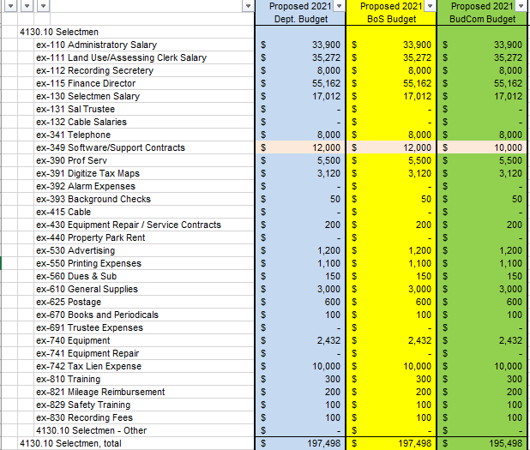

Jeff seconded the motion and the motion carried as follows:

In Favor of Motion |  | Opposed to Motion |  | Abstaining
Tom Billbrough |  | Sheila Johannesen
Sue Overstreet
Jeff Steenson

Next we reviewed the proposed FY2021 Auditing Contract budget (account 4150.20). At the conclusion Jeff made a motion to accept the proposed budget in the amount of $28,000. Sue seconded the motion and the motion carried unanimously.

We then reviewed the proposed FY2021 Information Technology budget (account 4150.60). At the conclusion of our review Jeff made a motion to accept the proposed budget in the amount of $56,589. Tom seconded the motion and the motion carried unanimously.
Next we reviewed the proposed FY2021 Legal Department (account 4153.10). At the conclusion Jeff made a motion to accept a modified budget in the amount of $40,500. Sue seconded the motion, however the motion failed to carry as follows:

In Favor of Motion |  | Opposed to Motion |  | Abstaining
Sue Overstreet |  | Tom Billbrough
Jeff Steenson |  | Sheila Johannesen

Tom then made a motion to accept a modified budget in the amount of $45,500 as follows:

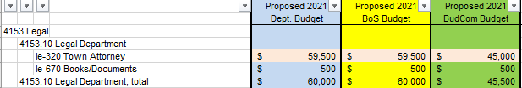

Jeff seconded the motion and the motion carried as follows:

In Favor of Motion |  | Opposed to Motion |  | Abstaining
Tom Billbrough |  | Sheila Johannesen
Sue Overstreet
Jeff Steenson

We then reviewed the proposed FY2021 Personnel budget (account 4155). At the conclusion of our review Tom made a motion to accept the proposed FY2021 in the amount of $459,812. Jeff seconded the motion and the motion carried unanimously.

Next we reviewed the proposed FY2021 Town building maintenance budget (account 4194.10). At the conclusion Tom made a motion to accept a modified budget in the amount of $70,040 as follows:

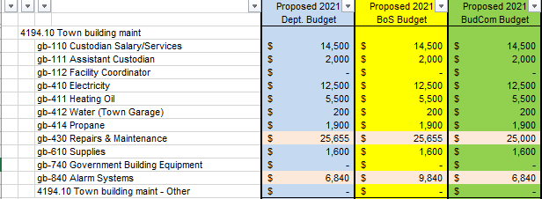

Sue seconded the motion and the motion carried as follows:

In Favor of Motion |  | Opposed to Motion |  | Abstaining
Tom Billbrough |  | Sheila Johannesen
Sue Overstreet
Jeff Steenson

Lastly, we reviewed the proposed FY2021 Community Center budget (account 4194-20). At the conclusion of our review Tom made a motion to accept the proposed budget in the amount of $27,510. Jeff seconded the motion and the motion carried unanimously.

With nothing further to discuss we adjourned the meeting at 9:03 PM.

Our next meeting will be Tuesday, January 5th 2021 at 7:30 PM in the Town Hall where we will begin our review of the proposed warrant articles as well as the proposed FY2021 estimated revenue.

Respectfully Submitted
Tom Billbrough
Chairperson

