FY2021 DANVILLE BUDGET COMMITTEE
Minutes of our November 17, 2020 meeting

Chairman Tom Billbrough called this kickoff meeting of the FY2021 Danville Budget Committee to order at 7:30 PM, with the following members present:

Tom Billbrough * | Present | Sue Overstreet | Present (via Zoom)
Rob Collins ** | Present (via Zoom) | David Rosati | Absent
Sheila Johannesen *** | Present | Jeff Steenson | Present (via Zoom)

* Chairperson
** Vice Chairperson
*** BOS Representative

The first subject of discussion was a review of the minutes from our November 10, 2020 meeting. At the conclusion of our review, Jeff made a motion to accept the minutes with a minor correction (the name of the member who made the motion to accept a modified Library budget as well as the name of the member who seconded the motion were incorrect). Sue seconded the motion and the motion carried unanimously.

At our November 10th meeting, the BudCom had discussed the desire to see an unbiased salary and wage review. With that in mind, Tom took the opportunity to let the BudCom (as well as the Fire Chief, Deputy Fire Chief and 2 Fire Wards who were present to discuss the proposed Fire Department budget) know that he was informed that the NH Wage and Salary review was still being published (electronically). This would enable to BudCom to facilitate an unbiased wage and salary review, comprised of representatives of the Town’s various departments and committees. Tom recommended that the review be made up of information from the 5 towns that border the Town of Danville and the towns that border those towns that border Danville.

Tom then went on to explain to the Fire Chiefs and Wards that at our November 10th meeting the BudCom had voted unanimously to limit all wage and salary increases for the FY2021 proposed budgets to only the 2% COLA recommended by the BoS, unless the increase was caused by a change in job scope or by an increase in personnel, thus implementing a “wage freeze” until an unbiased wage and salary review could be conducted.

After allowing the Fire Chief to explain why he felt a wage increase was justified, we proceeded to review the proposed FY2021 Fire Department budget (account 4220). As per the above limitation on salary increases the Fire Department representative presented their propose non-salary related budget line items. At the conclusion of our review, Jeff made a motion to accept a modified FY2021 budget in the amount of $407,377 (a 2.8% increase over last years approved budget) as follows:

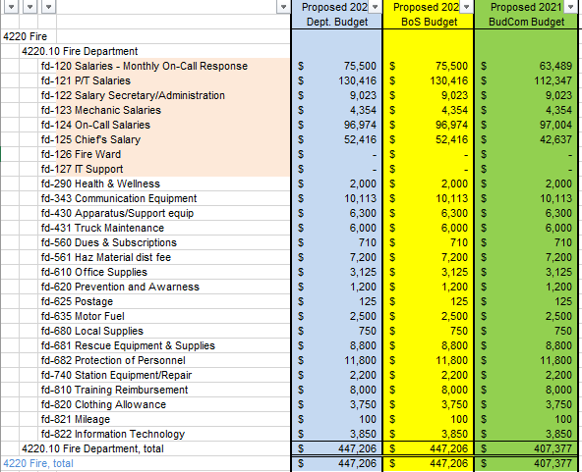
Sue seconded the motion and the motion carried as follows:

In Favor of Motion |  | Opposed to Motion |  | Abstaining
Tom Billbrough |  | Sheila Johannesen
Rob Collins
Sue Overstreet
Jeff Steenson

After thanking the Fire Department representatives and asking that they serve as our conscience and ensure that we do facility a review we continued to discuss several smaller proposed budges as follows:

Heritage Commission (account 4199): at the conclusion of our review, following discussion, we agreed to table further discussion until our next meeting to enable Tom to have a representative from the Heritage Commission to be present as it was proposed to cut the salary line from $1,562 to $1,200.

Accounting & Financial Reporting (formerly Trustee of Trust Funds, account 4150.10): Jeff made a motion to accept the proposed FY2021 budget in the amount of $2,966. The motion was seconded by Sheila and the motion carried unanimously.

Recreation (account 4589): Sue made a motion to accept the proposed FY2021 budget in the amount of $17,750. Rob seconded the motion and the motion carried as follows:

In Favor of Motion |  | Opposed to Motion |  | Abstaining
Tom Billbrough |  | Jeff Steenson
Rob Collins
Sheila Johannesen
Sue Overstreet

Health (account 4411): Jeff made a motion to accept a revised FY2021 budget in the amount of $27,942 as follows:

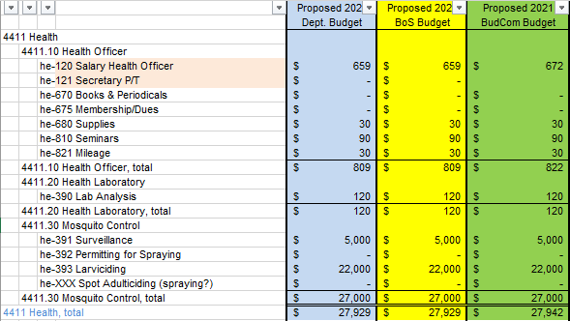

Sheila seconded the motion which carried as follows:

In Favor of Motion |  | Opposed to Motion |  | Abstaining
Tom Billbrough |  |  |  | Sue Overstreet
Rob Collins
Sheila Johannesen
Jeff Steenson

We then discussed and agreed that we would review the following budgets at our next meeting (scheduled for Tuesday, November 24, 2020 at 7:30 PM in the Town Hall):

- Heritage Commission (account 4199)
- Town Clerk (account 4140.10)
- Voter Registration (account 4140.20)
- Welfare (account 4440)

With nothing further to discuss the meeting adjourned at 9:17 PM.

Respectfully Submitted
Tom Billbrough
Chairperson

