FY2021 DANVILLE BUDGET COMMITTEE
Minutes of our January 5th, 2021 meeting

Chairman Tom Billbrough called this meeting of the FY2021 Danville Budget Committee to order at 7:31 PM, with the following members present:

Tom Billbrough * | Present | Sue Overstreet | Present (via Zoom)
Rob Collins ** | Present (via Zoom) | Jeff Steenson | Present (via Zoom)
Sheila Johannesen *** | Present (via Zoom)
* Chairperson
** Vice Chairperson
*** BOS Representative

The first subject of discussion was a review of the minutes from our December 29th, 2020 meeting. At the conclusion of our review, Jeff made a motion as written. Sue seconded the motion and the motion carried as follows:
In Favor of Motion |  | Opposed to Motion |  | Abstaining
Tom Billbrough |  |  |  | Rob Collins
Sheila Johannesen
Sue Overstreet
Jeff Steenson

We then proceeded to review the 9 FY2021 Warrant Articles recommended by the BoS. Tom read each warrant article, at which point we then discussed and voted to recommend or not-recommend. At the conclusion of the reading, Tom would that ask for those recommending the warrant to declare so, followed by those who were not recommending the warrant, followed by those abstaining. At the conclusion of our reviews we voted to recommend eight of the 9 warrant articles as follows:
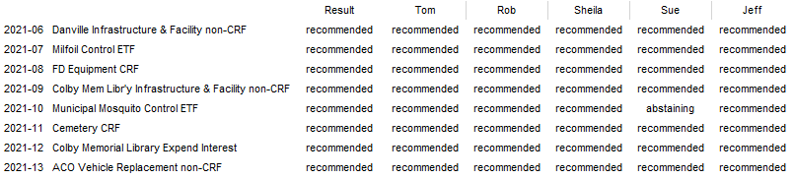

During our discussion of warrant 2021-05 (FD CRF for Future FD Vehicle Purchases, there were several questions as to justification for the request to add $100,000 to the Capital Reserve Fund, given that a new pumper was recently purchased and historically the amount requested was typically $50,000. As a result we agreed to table further discussion and invite the Fire Chief/Fire Wards to our next meet to give them the opportunity to justify the requested amount.

Next we developed our BudCom estimated 2021 revenue budget in the amount of $1,127,380 as shown on the following page.

Tom then presented some changes that he is proposing to make to the BudCom spreadsheet. A few years ago, the BoS voted to move the monies that were previously put into account 4155 (Personnel) as a result of the Library payroll (specifically Workman’s Compensation, Unemployment and SS/FICA/Medicare) from account 4155 to the Library account (4550) so that it would be obvious to those who looked at the budget details just how much having a library was costing the town.

In light of the large increase in the NH Retirement System dollars for the Police Department (an increase of $85,630 over the amount budgeted in 2020), Tom proposed that the monies in the FY2021 account 5155 (Personnel) for the top 4 budgets also be removed from account 5155 and reallocated to their respective budgets.

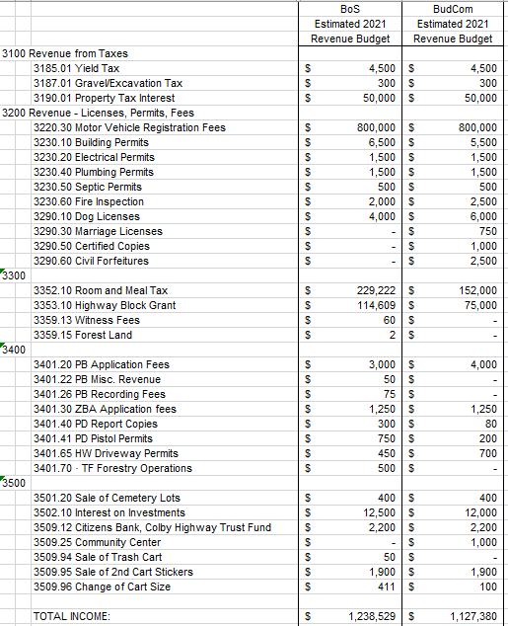

The affected budgets would be:

4312 Highways & Streets, total
4210 Police, total
4220 Fire, total
4550 Library, total

The BudCom unanimously agreed and requested that Tom attempt to make those changes in time for our Public Hearing.

Lastly we agreed to hold the FY2021 Public Hearing on Tuesday, January 19, 2021.

With nothing more to discuss, the meeting adjourned at 9:00 PM.

Our next meeting will be Tuesday, January 12th 2021 at 7:30 PM in the Town Hall.

Respectfully Submitted
Tom Billbrough
Chairperson

