FY2021 DANVILLE BUDGET COMMITTEE
Minutes of our December 15, 2020 meeting

Chairman Tom Billbrough called this meeting of the FY2021 Danville Budget Committee to order at 7:32 PM, with the following members present:

Tom Billbrough * | Present | Sue Overstreet | Present (via Zoom)
Rob Collins ** | Present (via Zoom) | Jeff Steenson | Present (via Zoom)
Sheila Johannesen *** | Present

* Chairperson
** Vice Chairperson
*** BOS Representative

The first subject of discussion was a review of the minutes from our December 1, 2020 meeting. At the conclusion of our review, Jeff made a motion as written. Sheila seconded the motion and the motion carried unanimously.

We then proceeded to review the proposed FY2021 Forestry budget (account 4619). We had table our discussion of this budget at our last meeting, asking that Sheila contact the forestry committee to get a breakdown of line item tf-830 (Special Projects). Carsten Springer from the Forestry Committee was present to answer our questions and provided that the dollars in that line were for repairs needed to the road used to access the Town Forest for the purposes of forestry management. At the conclusion of our review, Jeff made a motion to accept the proposed budget in the requested amount of $4,310. Rob seconded the motion and the motion carried unanimously.

Next we reviewed the proposed Tax Collection budget (4150.40); Kim Burnham (Tax Collector) was present to answer any question. At the conclusion of our review, Rob made a motion to accept a modified budget in the amount of $68,989 as follows:

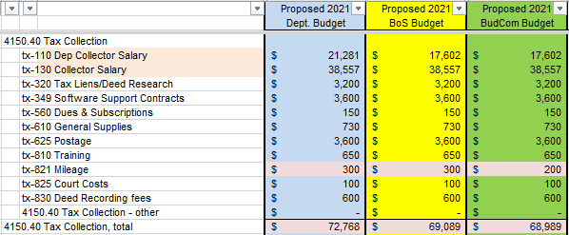

Jeff seconded the motion and the motion carried unanimously.

We then proceeded to review the proposed FY2021 Selectmen budget (account 4130.00). Shiela and Kim were present to answer questions (for this budget as well as all that follow). After a lengthy discussion on 4 out of the 5 salary lines

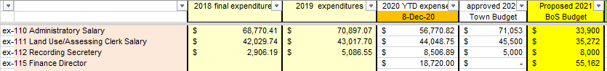

Rob agreed to write a formal request for salary information (e.g. name, hourly wage, # of hours per week, etc.) so that we would have data justifying the proposed amounts. We tabled further discussion on this account until our next meeting.

Next we began a review of the proposed FY2021 Legal budget (account 4153). Again, no data was available justifying and amounts requested. (The BudCom had asked for zero based budgeting, meaning “level funding” is not sufficient justification for a budget request). We again table further discussion until our next meeting.

We then proceeded to review the proposed FY2021 Insurance, Other budget (account 9196. At the conclusion of our review Sheila made a motion to accept the proposed budget in the amount of $49,776. Rob seconded the motion and the motion carried as follows:

In Favor of Motion |  | Opposed to Motion |  | Abstaining
Tom Billbrough |  | Rob Collins
Sheila Johannesen
Sue Overstreet
Jeff Steenson

Next we reviewed the proposed FY2021 Code Enforcement budget (account 4240). At the conclusion of our review Jeff made a motion to accept the proposed budget in the amount of $2,692. Sue seconded the motion and the motion carried unanimously.

We then reviewed the proposed FY2021 Street Lighting budget (account 4316). At the conclusion of our review Jeff made a motion to accept the proposed budget in the amount of $10,000. Sheila seconded the motion and the motion carried unanimously.

Lastly we reviewed the proposed FY2021 Parks & Recreation budget (account 4520). At the conclusion of our review Sue made a motion to accept the proposed budget in the amount of $33,600. Sheila seconded the motion and the motion carried unanimously.

With nothing further to discuss we adjourned the meeting at 9:21 PM.

Our next meeting will be Tuesday, December 22, 2021 at 7:30 PM in the Town Hall where we will attempt to complete our review of these remaining budgets:

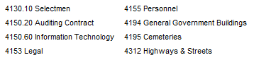

Respectfully Submitted
Tom Billbrough
Chairperson

