FY2021 DANVILLE BUDGET COMMITTEE
Minutes of our December 1, 2020 meeting

Chairman Tom Billbrough called this meeting of the FY2021 Danville Budget Committee to order at 7:30 PM, with the following members present:

Tom Billbrough * | Present | Sue Overstreet | Present (via Zoom)
Rob Collins ** | Present (via Zoom) | Jeff Steenson | Present (via Zoom)
Sheila Johannesen *** | Present (via Zoom)

* Chairperson
** Vice Chairperson
*** BOS Representative

The first subject of discussion was a review of the minutes from our November 24, 2020 meeting. At the conclusion of our review, Jeff made a motion as written. Sue seconded the motion and the motion carried unanimously.

We then started in with our review of the proposed FY2021 Police Department budget (account 4210.10); Chief Parsons and Lt. Merced were present to answer any questions. There were discussion regarding the large percentage increases to the salary line. Chief Parsons explained that the increases were due the desire to hire another full-time officer and to increase the number of part-time officers so that a the second shift would have two patrol cars on duty. At the conclusion of our review Rob made a motion to accept a modified budget in the amount of $561,843 as follows:

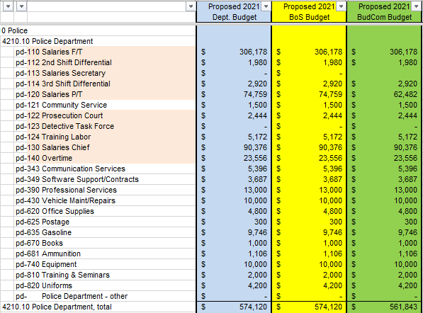

Jeff seconded the motion and the motion carried as follows:

In Favor of Motion |  | Opposed to Motion |  | Abstaining
Rob Collins |  | Tom Billbrough
Sheila Johannesen
Sue Overstreet
Jeff Steenson

Next we reviewed the proposed Animal Control budget (account 4210.20). At the conclusion of our review Jeff made a motion to accept the proposed budget in the amount of $7,768. Rob seconded the motion and the motion carried as shown on the following page.

We then started a discussion on the proposed Forestry budget (account 4619) but table discussion due to lack on supporting data on line tf-830 Special Projects. The committee asked Sheila to asked the Forestry Committee for details supporting the request for $3,500.
In Favor of Motion |  | Opposed to Motion |  | Abstaining
Tom Billbrough |  |  |  | Sheila Johannesen
Rob Collins
Sue Overstreet
Jeff Steenson

Next we reviewed the proposed FY2021 Revaluation of Property budget (account 4152). At the conclusion of our review Jeff made a motion to accept the proposed budget in the amount of $27,000. Sue seconded the motion and the motion carried unanimously.

We then proceeded to review the proposed FY2021 Waste Disposal & Recycling budget (account 4324). At this budget is made up of a contract, there was some discussion, but in the end Jeff made a motion to accept the proposed budget in the amount of $474,903. Rob seconded the motion and the motion passed unanimously.

Our last budget to review was Conservation (account 4611). At the conclusion of our review, Jeff made a motion to accept the proposed budget in the amount of $19,555. Sue seconded the motion, and the motion carried unanimously.

We then reviewed what budgets we have remaining and determined that due to the upcoming BoS review schedule there was nothing for us to review next week so we agreed that our next meeting would be on Tuesday the 15th of December when we would review the Highway Department budgets, leaving the remaining BoS budgets to be reviewed on our Tuesday December 22nd meeting.

With nothing further to discuss the meeting adjourned at 9:19 PM.

Respectfully Submitted
Tom Billbrough
Chairperson

