FY2021 DANVILLE BUDGET COMMITTEE
Minutes of our November 24, 2020 meeting

Chairman Tom Billbrough called this meeting of the FY2021 Danville Budget Committee to order at 7:30 PM, with the following members present:

Tom Billbrough * | Present | Sue Overstreet | Present (via Zoom)
Rob Collins ** | Present (via Zoom) | David Rosati | Absent
Sheila Johannesen *** | Present | Jeff Steenson | Present (via Zoom)

* Chairperson
** Vice Chairperson
*** BOS Representative

The first subject of discussion was a review of the minutes from our November 17, 2020 meeting. At the conclusion of our review, Jeff made a motion as written. Sue seconded the motion and the motion carried unanimously.

At our November 17th meeting, the BudCom had tabled discussion on our discussion on the proposed FY2020 Heritage Commission budget (account 4199) after a motion to accept a modified budget in the amount of $1,861 was made and seconded, when it was requested that a representative from the Heritage Commission be contacted and requested to come in. Carol Baird (chairperson) of the Heritage Commission was in attendance (remotely) tonight to participate in our continued discussion. At the end of our discussion, Jeff made a motion to accept a modified budget in the amount of $2,000 as follows:

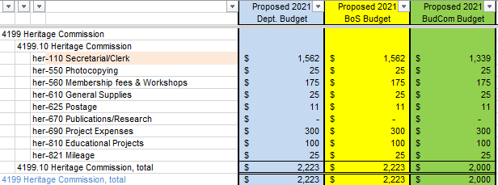

Rob seconded the motion, and the motion passed as follows:

In Favor of Motion |  | Opposed to Motion |  | Abstaining
Rob Collins |  | Tom Billbrough
Sue Overstreet |  | Sheila Johannesen
Jeff Steenson

We then had a brief discussion regarding the David Rosati’s attendance record – he has not attended any meeting, nor has he responded to numbers phone calls and emails. It was then a unanimous decision to request that the BoS proceed with removing David from the Budget Committee, thereby making the position available to another volunteer.

Next we had a lengthy review, along with Chris Tracy (Town Clerk) on the following budgets:

Town Clerk (account 4140.10) – during our discussions it was noted that the proposed Deputy Salary (line tc-110) did not adhere to the “COLA increase only” guideline. As a result, Jeff made a motion to accept a modified budget in the amount of $101,466 as shown on the next page.

Sue seconded the motion and the motion carried unanimously.

Voter Registration (account 4140.20) – during our discussion we found a math errors in the calculation in the line el-120 (Ballot Clerk Salary/Stipend and el-130 (Supervisors Salary/Stipend). Additionally we added an additional account line (el-135 - Deputy Moderator Salary/Stipend) as a new position, and we made use of an existing account

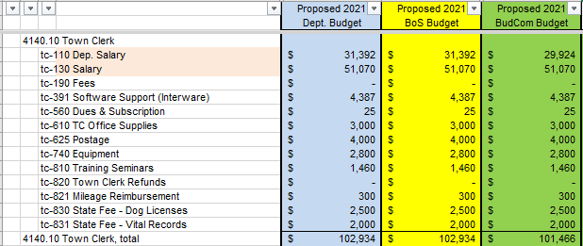

line (el-430 Ballot Machine Maintenance). At the conclusion of our review Rob made a motion to accept a modified budget in the amount of $16,602 as follows:

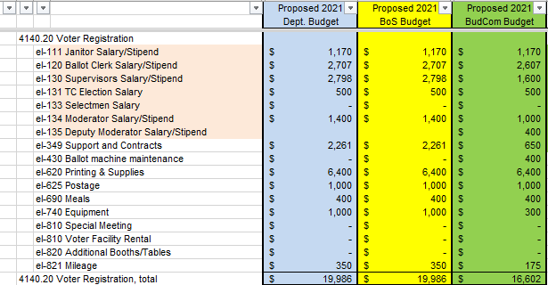

Sue seconded the motion and the motion carried unanimously.

General Assistance (account 4441.10) – after our discussion Jeff made a motion to accept the proposed budget in the amount of $7,807. Sue seconded the motion and the motion carried unanimously.

Direct Assistance (account 4442.10) – after our discussion Rob made a motion to accept the proposed budget in the amount of $24,700. Sue seconded the motion and the motion carried unanimously.

Vendor Payments (account 4445.20) – there was considerable discussion regarding the monies spent due to the Covid crisis and the fact that the Town’s financial summary does not show those expenses because they were posted to a grant rather than the expense line. This raised concern over the potential inadequacies of the proposed budget should the issues pertaining to the virus continue. In the end, we decided that none of us could predict the future. At the conclusion of our discussion Jeff mode a motion to accept the proposed budget in the amount of $30,982. Sheila seconded the motion and the motion carried as follows:

In Favor of Motion |  | Opposed to Motion |  | Abstaining
Tom Billbrough |  | Rob Collins
Sheila Johannesen
Sue Overstreet
Jeff Steenson

With nothing further to discuss the meeting adjourned at 9:57 PM.

Respectfully Submitted
Tom Billbrough
Chairperson

