FY2021 DANVILLE BUDGET COMMITTEE
Minutes of our November 10, 2020 meeting

Chairman Tom Billbrough called this kickoff meeting of the FY2021 Danville Budget Committee to order at 7:30 PM, with the following members present:

Tom Billbrough * | Present | Sue Overstreet | Present (via Zoom)
Rob Collins ** | Present (via Zoom) | David Rosati | Absent
Sheila Johannesen *** | Present | Jeff Steenson | Present (via Zoom)

* Chairperson
** Vice Chairperson
*** BOS Representative

The first subject of discussion was a review of the minutes from our October 13, 2020 meeting. At the conclusion of our review, Jeff made a motion to accept the minutes with a minor correction (both he and Rob were shown as being vice-chair in the attendance table when in fact Rob is the sole vice-chair). Sheila seconded the motion and the motion carried unanimously.

Next we reviewed the proposed Library budget (account 4550). Two of the 3 Library Trustees (Mary Elizabeth and Sarah) were present as were the Library Director (Ann Massoth) and Assistant Director (Tom Billbrough, Jr.). At the conclusion of our review, the Trustees were thanked for being frugal in their budget. Since the Library presented salary lines that did not include the 2% COLA increase recommended by the BoS, Jeff made a motion to fund the department in the amount of $266,634 as follows:

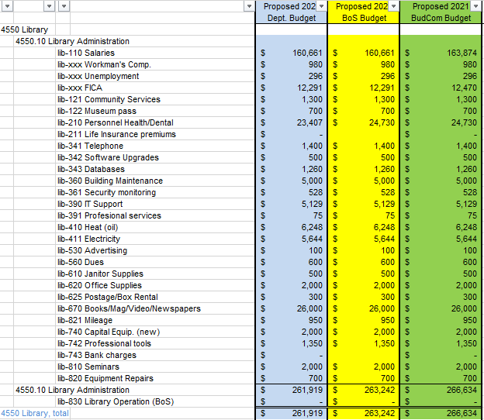

(The increases in lib-110 and in lib-xxx were due to the addition of the 2% COLA.) Rob seconded the motion, and the motion carried unanimously, with Tom abstaining.

We then had a discussion regarding wage surveys and salary increases. The consensus of the committee was that in recent years we’ve gone away from formal Town wide salary surveys, by either the BoS or the department conducting their own wage and salary reviews for selected individuals or departments. There is little consistency as to which Towns/Cities were surveyed, nor were department conducted surveys conducted by neutral parties. In addition, recent years have also seen the BoS or local departments giving unbudgeted raises to employees, utilizing funds that were justified during the budgeting process for other purposes. In short, the Town needs to conduct a salary and wage review, for ALL employees, conducted by a 3rd party or neutral source. At the conclusion of our discussion, Tom made a motion that the BudCom would not recommend ANY increases to salaries or wages above the BoS recommended 2% COLA unless the increase to the salary line was due to additional manpower or an increase in the job scope.

Rob seconded the motion, and the motion carried unanimously.

In continuing the lines of that subject, we discussed the possibility of a wage and salary review being done at the request of the BudCom. Tom agree to research how to add a wage & salary review line in the FY2021 BudCom budget so that funds would be available in 2021 to have such a survey conducted (assuming that the BudCom FY201 recommended budget is approved).

Next we reviewed several of the smaller proposed FY2021 budgets as follows:

Town Meeting (account 4130.30). A motion to fund this account in the requested amount of $2,000 was made by Jeff. Sheila seconded the motion and the motion carried unanimously.

Treasury (account 4150.50). A motion to fund this account in the amount of $11,361 was made by Rob (the addition to t-120 (Salary, Asst. Treasurer) and t-130 (Salary, Treasurer) was the inclusion of the BoS recommended 2% COLA) as follows:

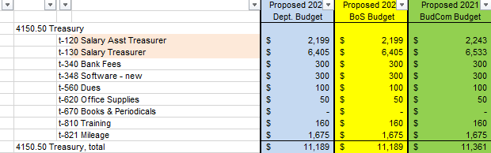

Sue seconded the motion and the motion carried unanimously.

Planning Board (account 4191.10). A motion to fund this account in the requested amount of $3,700 was made by Jeff. Rob seconded the motion and the motion carried unanimously.

Zoning Appeals (account 4191.30). A motion to fund this account in the requested amount of $845 was made by Jeff. Sheila seconded the motion and the motion carried unanimously.

Advertising & Regional Associations (account 4197). A motion to fund this account in the requested amount of $3,833 as made by Jeff. Rob seconded the motion and the motion carried unanimously.

Patriotic Purposes (account 4583). A motion to fund this account in the requested amount of $4,533 was made by Sheila. Jeff seconded the motion and the motion carried unanimously.

Lastly we attempted to review the proposed FY2021 Heritage Commission budget (account 4199). A discussion concerning the budget for the Secretarial/Clerk (line her-110) was held with recommendation to inform the Heritage Commission of the proposed cut from proposed $1,562 to $1,200 and invite them to email (or send a letter) with justification for the $1,562 since the past 3-year high was only $1,000 or to contact us to schedule a review at an upcoming meeting. Unfortunately Tom’s phone “died” abruptly ending the meeting before any vote or decision could be made.

Our next meeting is scheduled for Tuesday, November 17, 2020 at 7:30 in the Town Hall. We will be reviewing the proposed Fire Department budget as well as any other budgets presented by the BoS representative.

With no further to discussion possible, the meeting adjourned at 9:27 PM.

Respectfully Submitted
Tom Billbrough
Chairperson

