FY2021 DANVILLE BUDGET COMMITTEE
Minutes of our October 13, 2020 meeting

Chairman Tom Billbrough called this kickoff meeting of the FY2021 Danville Budget Committee to order at 7:30 PM, with the following members present:

Tom Billbrough * | Present | Sue Overstreet | Present
Rob Collins ** | Present (via Zoom) | David Rosati | Absent
Sheila Johannesen *** | Present | Jeff Steenson ** | Present (via Zoom)

* Chairperson
** Vice Chairperson
*** BOS Representative

The first subject of discussion was confirmation of our meeting day and time, which we agreed would be Tuesday evenings at 7:30 PM at the Town Hall. Members can attend either remotely or in person (masks and social distancing required).

Next we agreed that we would not be meeting jointly with the BOS to review budgets as members of the BudCom were not willing to meet with the BOS if masks and social distancing were not required and the BOS was unwilling to meet with the BudCom on our “normal” meeting date and time.

As usual the BudCom meetings will adhere (loosely) to Robert’s Rules where attendance by the majority of the committee members, defined as >50% (i.e. 4 members) would constitute a quorum for a meeting, and a vote of >50% of the members present would be considered a majority rule.

Like previous years the BudCom agreed to concentrate on the budgets that make up 80% of the budget dollars as follows:
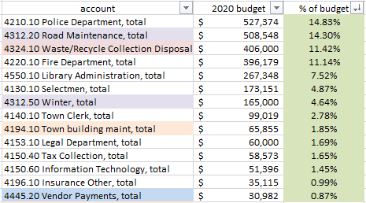

Additionally, we would review any budget that changed by >10% over the past year, as well as the following budgets (associated with budgets previously listed as part of the 80%), an any other budget as requested by a member:
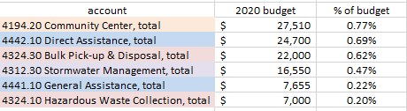

Next we reviewed the proposed FY2021 Emergency Management budget (account 4290.10). At the conclusion of our review Jeff made a motion to accept the budget in the recommended amount of $8,076. Sue seconded the motion which carried unanimously.

We then reviewed the proposed FY2021 Dams budget (account 4319). At the conclusion of our review Jeff made a motion to accept the budget in the recommended amount of $134. Rob seconded the motion which carried unanimously.

Next we reviewed the proposed FY2021 Interest on TAN budget (account 4723). At the conclusion of our review Jeff made a motion to accept the budget in the recommended amount of $1,500. Rob seconded the motion which carried unanimously

We then proceeded to elect the FY2021 BudCom Chairperson and Vice Chairperson: Jeff made a motion for Tom to continue as Chair. Sue seconded the motion which passed unanimously, with Tom abstaining.

Jeff then made a motion for Rob to continue as Vice Chair. Sheila seconded the motion which passed unanimously, with Rob abstaining. Sheila then requested that Rob continue to maintain the BudCom web page, to which he agreed.

Lastly we reviewed the upcoming BOS budget schedule and decided that our next meeting would be Tuesday, October 27, 2020.

With nothing further to discuss the meeting adjourned at 8:05 PM.

Respectfully Submitted
Tom Billbrough
Chairperson

